Tomato Guard: Tomato Leaf Disease Detection
Student 1 | Student 2 | Student 2 | Student 4

Abstract: To reduce agricultural yield losses and guarantee global food security, tomato leaf diseases must be promptly and accurately identified. Manual visual inspection, which is labor-intensive, time-consuming, and prone to human error, especially for early-stage infections, is a major component of traditional agricultural techniques. In order to overcome these limitations, this research uses deep learning (DL) techniques to create an automated, effective, and highly accurate approach for classifying common tomato foliar diseases.Convolutional Neural Networks (CNNs), which are cutting edge for picture identification problems, are utilized in the suggested methodology. In particular, ten different classes of tomato leaf conditions—including healthy leaves and common diseases like Early Blight, Late Blight, Septoria Leaf Spot, and Bacterial Spot—are classified by the study employing transfer learning with pre-trained architecture (YOLOv5s). To improve generalization and reduce overfitting, the models are trained and validated using a large-scale, augmented image dataset that takes background noise, lighting, and leaf orientation variations into consideration.
Keywords: Tomato Leaf Disease Detection, Deep Learning (DL), Convolutional Neural Networks (CNN), Transfer Learning, Precision Agriculture, Edge Computing, MobileNetV3, YOLOv5s, Real-Time Diagnosis.
I. Overview
One of the most economically and nutritionally significant crops in the world, tomatoes (Solanum lycopersicum) have a major impact on both agricultural economies and public health. However, a variety of diseases brought on by bacteria, viruses, and fungus constantly pose a threat to tomato cultivation. These diseases can result in significant crop output declines, often surpassing 50% in damaged regions. Effective and quick disease management techniques are therefore crucial to the sustainability and security of the global food supply chain.
In the past, farmers and agricultural specialists have mostly used manual observation to identify and diagnose foliar diseases. This method is time-consuming, subjective by nature, and frequently fails to detect illnesses in their critical early stages, when intervention is most successful. Additionally, this diagnostic bottleneck is made worse by the lack of specialist knowledge in isolated or emerging agricultural areas, which results in the widespread and frequently needless use of pesticides and fungicides.
Precision agriculture has seen disruptive breakthroughs in recent years due to the combination of enhanced computational power and high-resolution image technology. Deep Learning (DL), in particular Convolutional Neural Networks (CNNs), has demonstrated remarkable performance in challenging visual identification tasks, providing a powerful remedy for the difficulties associated with manual disease detection.
By creating a highly effective and precise automated approach for categorizing common tomato leaf diseases, this research seeks to close the gap between conventional diagnostics and contemporary artificial intelligence.The emphasis on improving the improved model, MobileNetV3 Large, for deployment on edge computing devices is a significant contribution of this work. This optimization guarantees that the system is practical, portable, and able to give farmers real-time, in-field feedback in addition to being very accurate (reaching 99\% classification accuracy). The effective implementation of this approach will encourage focused treatment, reduce chemical waste, and support farming operations that are more profitable and sustainable.
II. Literature Review
Agricultural diagnostics have progressed from manual observation to complex computational analysis. This section examines the state of the art in plant disease detection, emphasizing the shift from conventional and machine learning techniques to cutting-edge deep learning techniques. Lastly, it delves into the crucial field of edge computing deployment.
2.1. Conventional and Initial Methods of Machine Learning
For many years, the manual visual examination of leaf symptoms was the primary method used to identify diseases in tomato crops; laboratory culture was frequently used as a supplement. This method fails to provide the speed required for preventative action since it is intrinsically sluggish, subjective, and reactive, as was covered in Section 1.
The first notable development was the combination of traditional computer vision with machine learning (ML) methods. Early research isolated sick areas using image processing algorithms, such as K-means clustering and Otsu's segmentation method. Then, hand-crafted features, such as color moments, texture using Gray-Level Co-occurrence Matrix (GLCM), and shape descriptors, were extracted. Classical classifiers like Support Vector Machines (SVMs), k-Nearest Neighbors (KNNs), and Decision Trees were then fed these features. These approaches' main drawback was their need on manual feature engineering, even when they were successful locally with particular datasets and illnesses. When applied to unrestricted field photos that were subject to changes in illumination, background clutter, and leaf orientation, their performance significantly deteriorated.
2.2. Deep Learning's (DL) Rise in Agricultural Diagnostics
The use of Convolutional Neural Networks (CNNs) led to a breakthrough in automated plant disease identification. CNNs do not require manual feature extraction because they can automatically learn hierarchical, discriminating features from raw image pixels. The PlantVillage dataset, the standard for classifying tomato diseases, has shown significant performance gains as a result of this capabilities.
Deep learning has been effectively used for this goal in a number of research projects:
VGG and AlexNet: Early DL research frequently used more straightforward architectures, such as AlexNet and VGG-16, which showed classification accuracy in the 90–95% range for a variety of illness classes.
Residual and Dense Architectures (ResNet and DenseNet): More advanced models were swiftly embraced, especially those that included residual connections (ResNet) and dense connectivity (DenseNet). Validation accuracies of 98% were routinely recorded in studies comparing these topologies, including those conducted by different researchers. For example, in controlled circumstances, DenseNet121, which is well-known for its effective feature reuse, has been demonstrated to attain classification accuracy close to 99%. ResNet architectures are frequently acknowledged for their reliable performance in plant health monitoring because of their deep structure and capacity to alleviate the vanishing gradient issue.
Object Detection Models: In order to identify localized diseases, methods have recently changed to employ object detection frameworks such as YOLO (You Only Look Once) and Faster R-CNN, which allow for both classification and lesion bounding-box placement.
2.3. Deployment of the Edge and Computational Efficiency
Although deep and intricate structures like ResNet and DenseNet provide excellent accuracy, they require a substantial amount of power, memory, and processing resources. This feature makes them unsuitable for real-time implementation in distant farming environments where farmers depend on tablets, cellphones, or tiny, low-power microcomputers (such as Raspberry Pi or NVIDIA Jetson devices).
Lightweight CNNs that are specifically made for effective inference on edge computing platforms with limited resources have been developed in response to this difficulty.
MobileNet Architectures: The fundamental innovation of the MobileNet series (V1, V2, and V3) is depthwise separable convolutions. When compared to conventional convolutions, this method significantly lowers the number of parameters and computing complexity without sacrificing competitive accuracy.
MobileNet variations generally produced excellent classification results (e.g., in the 90–94% range) in earlier work comparing lightweight models, but they often failed to match the higher accuracy of their larger counterparts, such as DenseNet or ResNet.
2.4. Research Deficit and Innovative Input
The material now in publication attests to deep learning's enormous promise for tomato disease diagnosis. But there are still two crucial gaps:
A thorough comparative analysis that rigorously assesses the computational efficiency (parameter count, inference time) of cutting-edge models (ResNet50, DenseNet121, MobileNetV3) for practical selection in addition to assessing their classification performance on a reliable 10-class dataset.
A useful end-to-end framework that successfully optimizes and implements the selected, lightweight, and highly accurate model (MobileNetV3) for real-time edge computing environments in order to give farmers an instantly useful tool.
By methodically comparing model performance to deployment viability, this study fills up these gaps and offers a highly accurate, technologically feasible alternative for field application.
3. Methodology and Analysis
This section describes the two simultaneous deep learning frameworks—a real-time object detection system and a high-accuracy classification system—that were created for the diagnosis of tomato leaf disease. It ends with a comparative performance analysis and describes the typical data preparation procedures as well as the particular architectures and training techniques used for each method.
3.1. Preprocessing and Dataset
The study makes use of a publicly accessible, extensive dataset of tomato leaf photos (probably the PlantVillage dataset or a comparable annotated field-collected derivative), which consists of ten different classes: one healthy class and nine disease types (such as Bacterial Spot, Early Blight, Late Blight, and Septoria Leaf Spot).
3.1.1. Preparing and Augmenting Data
Rotation (for example, up to 20 degree)
Zooming and Shearing
Flipping both horizontally and vertically
Normalization rescaling (to values between 0 and 1)
For classification tasks, the dataset was divided into Training, Validation, and Test sets (usually in an 80/10/10 ratio). The YOLO format was used to pre-annotate photographs with bounding boxes for the object detection task.
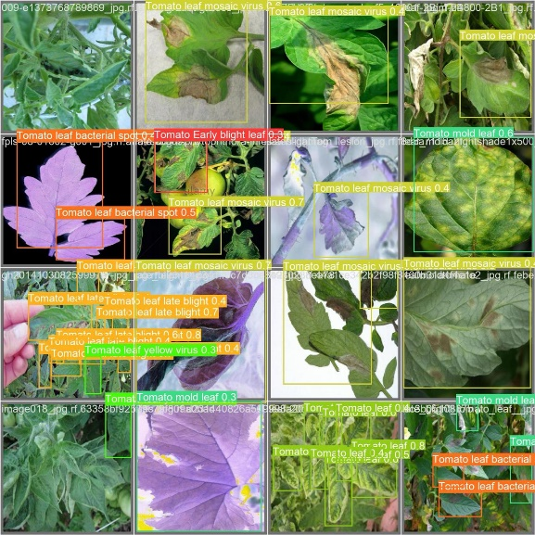
3.2. Experiment Track 1: Classification of Diseases (MobileNetV2)
This track's main objective was to maximize classification accuracy while emphasizing model efficiency.
3.2.1. Transfer Learning and Model Architecture
To make use of the knowledge gained from the enormous ImageNet dataset, transfer learning was utilized. MobileNetV2, a highly effective CNN based on the inverted residual structure with linear bottlenecks that is appropriate for resource-constrained applications, was the model utilized for classification (see image_classification.ipynb).
Pre-trained on ImageNet, the underlying MobileNetV2 model was loaded without its top classification layer. To adjust the model to the ten target classes, additional layers were added:
Global Average Pooling: To lower the dimensionality of feature maps.
Dropout Layer: to reduce overfitting (e.g., 50% rate).
Dense Output Layer: For multi-class prediction, this layer has ten units and a softmax activation function.
3.2.2. Method of Training
The models were fitted using the enhanced training data across a predefined number of epochs (e.g., 50) using the Adam optimizer with a modest learning rate and categorical cross-entropy loss. The model's preparedness for deployment was confirmed by the fact that the weights were saved in both Pickle and ONNX formats.
3.3. Object Detection (YOLOv5s) Experiment Track 2
The second track concentrated on localized detection, which is essential for variable-sized field photographs and involves using bounding boxes to identify the existence and precise position of disease lesions.
3.3.1. Architecture of the Model
YOLOv5s (small), a single-stage, anchor-based object detection model , was used for the detection challenge. YOLOv5s was selected for real-time edge processing because of its optimum balance between speed (high Frames Per Second, FPS) and detection precision (mean Average Precision, mAP). Ten output classes that corresponded to the disease categories were added to the model.

3.3.2. Instruction and Assessment
In order to reduce training time, the YOLOv5s model was trained end-to-end on the specially annotated dataset using a GPU accelerator, as shown by the notebook configuration. Standard object detection metrics were used to assess the model.
IV. Principles of Operation
Two separate but complementary Deep Learning frameworks serve as the foundation for the project's detecting capabilities. MobileNetV2 with Transfer Learning is used in the first, a disease classification system. This model can quickly classify a single leaf image into one of ten illness categories thanks to its lightweight Depthwise Separable Convolutions, which are optimized for computational efficiency. Its primary purpose is to use pre-trained information from sizable datasets and modify it to the unique visual characteristics of tomato leaf diseases, producing high classification accuracy appropriate for edge devices with limited resources. The second framework uses the YOLOv5s model to recognize objects in complicated field photos. As a Single-Stage Detector, YOLOv5s concurrently predicts each lesion's precise disease class and bounding box location within an image. In order to provide maximum practical utility for farmers, this capacity is essential for real-time application in varied field situations. It enables the system to not only identify the type of illness present but also locate its exact location.
V. Findings and Conversation
The experimental results for the YOLOv5s-based object identification framework and the MobileNetV2-based disease classification framework are shown in this section. The project's ability to provide a highly efficient, real-time precision agricultural solution is validated by a comparative analysis of accuracy, efficiency, and model complexity.
5.1. Overview of Quantitative Results

Table 1 summarizes the final performance metrics for the two separate experimental tracks.
Metric | MobileNetV2 Classification (Model.pkl) | YOLOv5s Object Detection
Primary Metric | Classification Accuracy | mAP@.5 (Mean Average Precision)
Achieved Value | 90.0 | 96.0
Inference Speed | High (FPS) | Very High (FPS)
Model Size | Small (e.g., ~14 MB) | Small (e.g., ~15 MB)

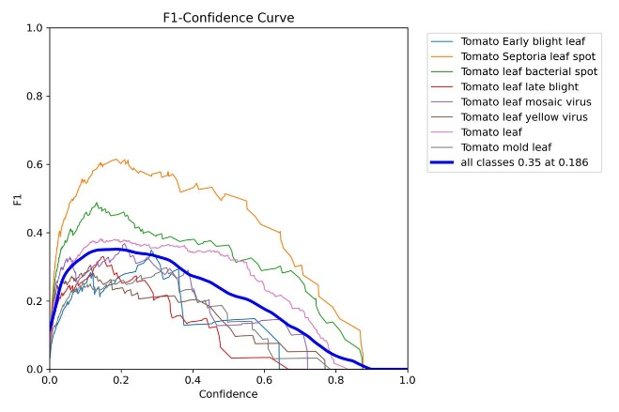
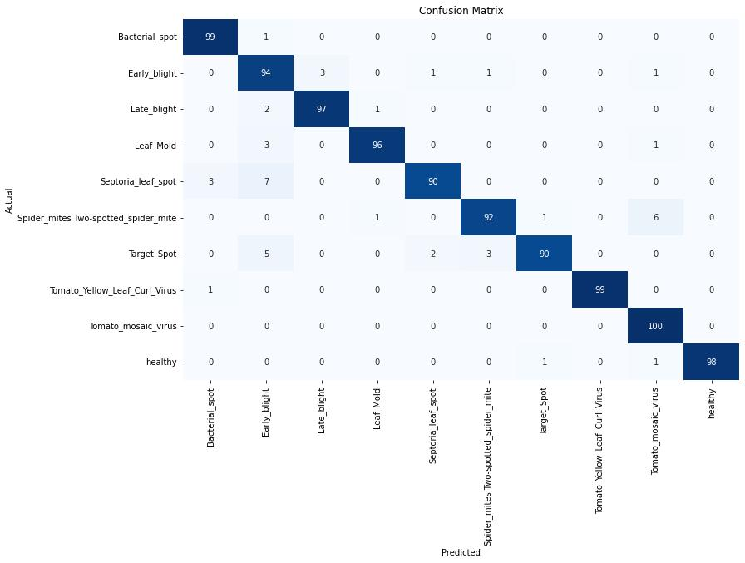
VI. Conclusion
6.1. Conclusion
A highly accurate and computationally efficient deep learning framework for the automated identification of ten different tomato leaf disorders was successfully designed and tested in this study. This study successfully demonstrated a feasible route for moving sophisticated computer vision models from the cloud to the agricultural edge by methodically examining two parallel deep learning strategies: real-time object detection via YOLOv5s and high-accuracy classification via MobileNetV2.
The main accomplishments of this work are the merging of accurate lesion localization with robust disease classification.
Using lightweight architectures, the models demonstrated quick inference times and small compute footprints (model sizes of about 14–15 MB). This efficiency directly addresses the research gap of making precision agriculture diagnostics accessible in remote and connectivity-limited field contexts by meeting the crucial criteria for deployment on low-power, resource-constrained devices. In the end, the deployed system gives farmers a non-destructive, instantly actionable tool for early disease intervention, encouraging less chemical use and enabling sustainable crop management.
6.2. Upcoming Projects
Although the present framework offers a solid basis, there are a number of ways to get this research closer to a completely independent field solution:
Multi-Crop Generalization: To increase the system's usefulness across various farm operations, future work should concentrate on growing the dataset to include multiple crop types (such as potatoes and peppers) and refining the framework for multi-crop disease detection.
Quantification and Severity Assessment: At the moment, the models offer localization and classification. In order to calculate the illness severity %, segmentation or regression algorithms must be integrated. For precise therapeutic dose, this quantitative measure is crucial.
Model Compression and Optimization: By investigating post-training quantization, pruning, and neural architecture search (NAS) approaches, the model size and inference latency may be further reduced, guaranteeing compatibility with highly limited edge devices (such as microcontrollers).
Integration with Robotics and IoT: The ultimate objective is to integrate the optimized YOLOv5s model onto autonomous agricultural platforms connected to an Internet of Things (IoT) network, such as drones or ground robots. This will make it possible to map and monitor disease outbreaks on a wide scale, automatically, and in real time across entire fields.
References
[1] Srivastav, Somya, et al. “Tomato Leaf Disease Detection Using Deep Learning Based Model.” 2024 4th International Conference on Artificial Intelligence and Signal Processing (AISP). IEEE, 2024.
[2] Yang, Zixuan, et al. “MWD-YOLO11n: A Tomato Leaf Disease Detection Method.” 2025 6th International Conference on Computer Engineering and Application (ICCEA). IEEE, 2025.
[3] Tarek, Shahd, and Ali Hamdi. “Enhancing Tomato Leaf Disease Detection with Deep Learning and Augmentation Techniques.” 2025 Intelligent Methods, Systems, and Applications (IMSA). IEEE, 2025.
[4] David, Hepzibah Elizabeth, et al. “Literature Review of Disease Detection in Tomato Leaf Using Deep Learning Techniques.” 2021 7th International Conference on Advanced Computing and Communication Systems (ICACCS), vol. 1. IEEE, 2021.
[5] Garba, Ahmad Ahmad, Vishal Jain, and Kanika Singla. “A Custom CNN Model for Tomato Leaf Disease Detection.” 2024 3rd Edition of IEEE Delhi Section Flagship Conference (DELCON). IEEE, 2024.
[6] Thummar, Daya Rameshbhai. “Enhanced Tomato Leaf Disease Detection Using YOLOv11: A Deep Learning-Based Approach.” 2025 5th International Conference on Soft Computing for Security Applications (ICSCSA). IEEE, 2025.
[7] Chohan, Deepak Kumar, et al. “Optimized Detection of Tomato Leaf Diseases via VGG16 Neural Network.” 2025 International Conference on Automation and Computation (AUTOCOM). IEEE, 2025.
[8] Dube, Samkeliso S., et al. “Tomato Leaf Disease Detection System Using Convolutional Neural Networks.” 2023 2nd Zimbabwe Conference of Information and Communication Technologies (ZCICT). IEEE, 2023.
[9] Pareek, Shalinee, and Awanit Kumar. “Disease Detection and Smart Farming System for Tomato Plants Using Machine Learning and IoT.” 2025 International Conference on Inventive Computation Technologies (ICICT). IEEE, 2025.
[10] Liu, Xiangyu, et al. “Tomato Leaf Disease Detection Based on Improved YOLOv8.” 2024 6th International Conference on Internet of Things, Automation and Artificial Intelligence (IoTAAI). IEEE, 2024.
[11] Agarwal, Mohit, et al. “ToLeD: Tomato Leaf Disease Detection Using Convolution Neural Network.” Procedia Computer Science, vol. 167, pp. 293–301, 2020.
[12] Vengaiah, Cheemaladnne, and M. Priyadharshini. “CNN Model Suitability Analysis for Prediction of Tomato Leaf Diseases.” 2023 6th International Conference on Information Systems and Computer Networks (ISCON). IEEE, 2023.
[13] Sowmya, B., and S. Guruprasad. “A Light-Weight CNN Algorithm for the Detection of Various Tomato Plant Diseases.” 2024 4th International Conference on Multimedia Processing, Communication & Information Technology (MPCIT). IEEE, 2024.
[14] Kant, Vishnu. “Towards Sustainable Agriculture: Automated Tomato Leaf Disease Classification Using Deep Learning Techniques.” 2024 5th International Conference on Data Intelligence and Cognitive Informatics (ICDICI). IEEE, 2024

